FOR PRESENTERS (SPEAKERS): ADDING DOCUMENTS TO YOUR SESSION(S)

Additional materials: For accessibility purposes, we ask that you provide your slide deck whenever possible. We encourage you to share supplemental materials (slide decks, handouts, etc.) by sharing a link to your materials in the session description. One suggestion is to upload all of your materials into a Google Drive folder, and then create an openly available link to that folder. We also recommend leaving your files in their native form (Google Doc, Google Slides, Word, PowerPoint, etc.) rather than converting them to PDF, as that can create issues for individuals using screen readers.

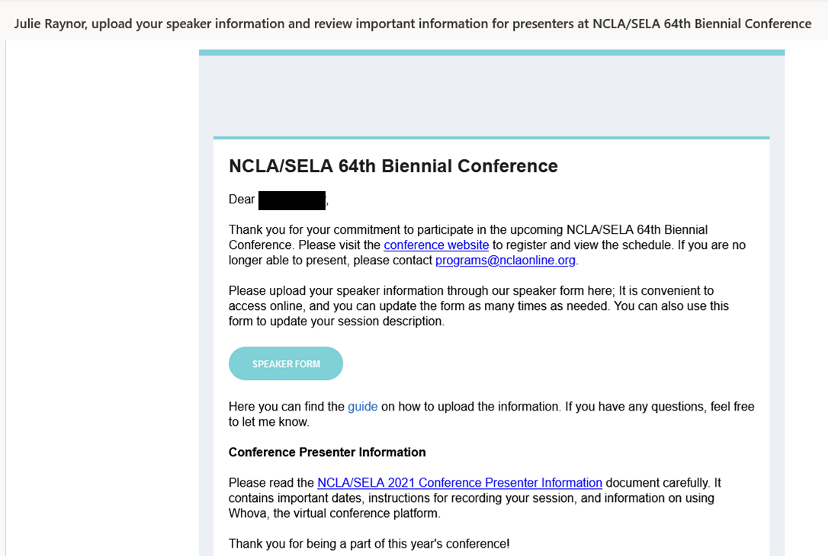
Log into your Whova Speaker Form and scroll down to your session.

You should have received an email (looks like this one) that gives you a link to your Speaker Profile information.

You can edit your session(s) and add in the Google Drive links in there.

Scroll to the bottom of the Description box and add a heading, such as “Go here for supplemental files”.

Then click the Insert/edit link and add in the link to the Google Drive folder.

